1. I am creating my models off the social media platform YouTube, this document is about the base/free version of YouTube.
2. Problem Domain Model for YouTube:  
   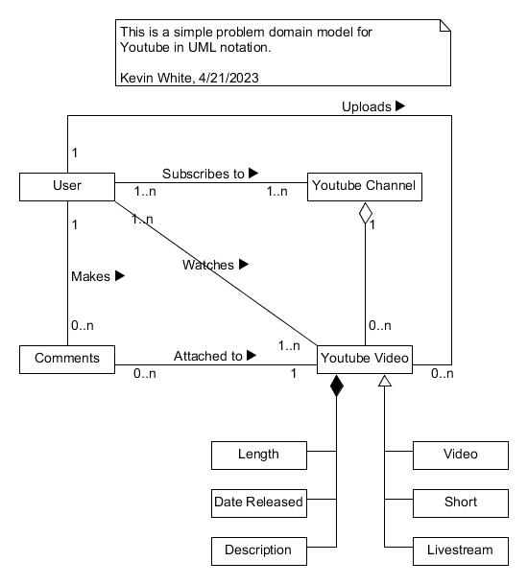
3. Use Case Diagram for YouTube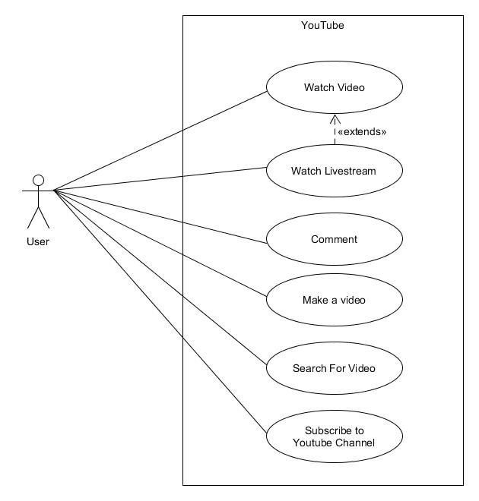
4. Use Case Diagram

|  |  |  |
| --- | --- | --- |
| **Use Case ID** | UC-1 | |
| **Use Case Name** | Watch a Video | |
| **Brief Description** | This use case describes what is like to find and watch a video on YouTube | |
| **Frequency of Use** | High-99% | |
| **Priority** | High | |
| **Current Version** | 1.0 | |
| **Date of First Version** | 4/21/2023 | |
| **Date of Last Version** | 4/21/2023 | |
| **Created By** | Kevin White | |
| **Last Update By** | Kevin White | |
| **Approved By** | N/A | |
| **Assumptions** | We are using the base version of YouTube, with adds. The user is watching this on a logged in google chrome account. | |
| **Primary Actor** | Everyday User | |
| **Secondary Actor/s** | N/A | |
| **Preconditions** | The User is already logged into the system | |
| **Postconditions** | The user is logged in and has watched a YouTube video | |
| **Trigger** | N/A | |
| **Main Success Scenario** | **User Actions** | **System Actions** |
|  | 1. The suer opens the application.  4. The user browses the homepage for a video.  5. The user clicks on a video.  8. The user clicks the “Skip Add” button.  10. The user Clicks full screen on the video. | 2. The system syncs the YouTube log in with the currently logged in default chrome profile.  3. The System Displays the YouTube homepage.  6. The system takes the user to the videos YouTube page.  7. The system gives the user and add before the video.  9. The system removes add and gives user the video.    11. The video takes up the full screen. |
| **Alternate Scenarios** | 10.a The user Can’t understand the video.  11.a The user clicks the settings options for the video.  13.a The user clicks on the audio tracks option.  15.a The user clicks on the audio track they can understand.    17.a The user is listening to a dubbed version of the same video in their language of choice. | 12.a The system displays options for the video.  14.a The system provides available audio tracks for the user.  16.a The system changes the audio track to the one picked by the user. |
| **Additional Notes (Constraints, etc.)** | Not all videos have Alternative audio tracks, these have to be uploaded by the video creator. | |

1. Requirements

|  |  |  |
| --- | --- | --- |
| **Req ID** | **Priority** | **Requirement Text** |
| **YouTube-Func-Req-1** | High | The System shall recommend the user content to keep the user on the platform for longer. |
| **YouTube-Func-Req-2** | High | The System shall allow user to easily reset. |
| **YouTube-Func-Req-3** | Medium | The System shall allow the user to search though the systems video database. |
| **YouTube-Func-Req-4** | Low | The System shall render videos to at least 1080p for a better viewing experience. |
| **YouTube-Hard-Req-1** | High | The System shall include at least 1 screen to view the UI. |
| **YouTube-Hard-Req-2** | Low | The System shall include at least 1 NIC, to establish internet connection. |
| **YouTube-Use-Req-1** | High | The System shall be intuitive and easy to learn, for any user. |
| **YouTube-Use-Req-2** | Medium | The System shall accept logins for multiple devices at once. |
| **YouTube-Pref-Req-1** | High | The System shall send data to the user device at a minimum 0.7Mbps |
| **YouTube-Pref-Req-2** | High | The System shall not redirect user to an unselected video. |
| **YouTube-Sec-Req-1** | High | The System shall remove public connection between a user’s email and YouTube account. |
| **YouTube-Sec-Req-2** | High | The System shall notify the user whenever they are leaving Youtube.com through a link |

1. Test case

|  |  |
| --- | --- |
| **Test Case ID** | UC-1 |
| **Test Case Name** | User Interface Testing |
| **Brief Description** | This test case shall test that all aspects of the user interface work as intended. |
| **Planned Test Duration** | 15 Minets |
| **Current Version** | 1.0 |
| **Date of Last Version** | 4/21/2023 |
| **Created By** | Kevin White |
| **Last Update By** | Kevin White |
| **Approved By** | N/A |
| **The version of Software Under Test** | 1.0 |
| **Test Engineer to Conduct the Test** | Kevin White |
| **List of Test Support Software** | Windows 11, Google Chrome |
| **List of Test Support Hardware** | 8 GB Memory, i7 GPU, Wireless Adapter |

**Test Case Scenario**

|  |  |  |  |
| --- | --- | --- | --- |
| **Test Step Number** | **Input** | **Expected** | **Result (Pass/Fail)** |
| 1 | Input “Youtube.com” into internet browsers search bar. | The System should start to run. | Pass |
| 2 | The user types “Marques Brownlee” into the search bar on the top of the website. | The System should pull up Marques Brownlee’s YouTube channel banner and related videos. | Pass |
| 3 | The user clicks on the channel banner with the title “Marques Brownlee”. | The System should take the user to Marques Brownlee’s YouTube channel. | Pass |
| 4 | The user clicks the “Shorts” tab | The System should display all Shorts uploaded by the user Marquese Brownlee | Pass |
| 5 | The user clicks the “Live” tab | The System should display all livestreams hosted by the user Marquese Brownlee | Pass |
| 6 | The user clicks the “Video” tab. | The System should display all videos uploaded by the user Marquese Brownlee | Pass |
| 7 | The user clicks on the first video in the video list. | The System should take the user to the video clicked on by the user | Pass |
| 8 | The user clicks on the description box with view count and time since release | The System should expand the description (If more is available) | Pass |
| 9 | The User Click the play icon | The System should start playing the video | Pass |
| 10 | The user hovers over the sound icon and drags the node left and right | The system should adjust the volume accordingly to the node | Pass |